# N A M E :

**DAILY ACTIVITIES**



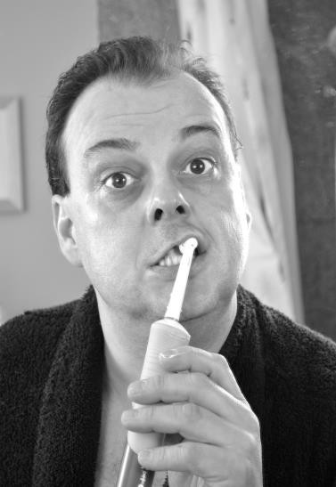⚫ **Complete the 15 sentences with the words on the left.**

_________________

|  |  |  |  |
| --- | --- | --- | --- |
| **A** | afternoon *n.* | **1.**  **2.**  **3.**  **4.**  **5.**  **6.**  **7.**  **8.**  **9.**  **10.**  **11.**  **12.**  **13.**  **14.**  **15.** | My _ always wakes me up at six o’clock every morning.  I wake up at six, but I **get up** at six-thirty.  Then, I go to the bathroom to get washed and  **brush my teeth** . Healthy teeth are important!  After that, I **get dressed** . I like to wear a tie. Then, I usually have a big **breakfast** .  I like to have some coffee, toast, and fruit.  I always **take a bus**  to my office.  At noon, I have **lunch** with my co-workers. We eat at a restaurant near our company.  In the **afternoon** I take a bus to go back home. I get back home at about five o’clock.  After I get home, I often **do exercise** . I like to go jogging. Sometimes I do sit-ups.  After that, I **take a shower** so that I can feel clean and fresh.  Then, I often help my wife **do housework** . For example, I sweep the floor and throw away the garbage.  I like to help my kids **do homework** . Sometimes my son needs help with his math.  I have **dinner** with my family in the dining room.  In the evening, we **relax** and watch TV. I **go to bed** between ten and ten-thirty. |
|  | alarm clock *n.* |
| **B** | breakfast *n.* |
|  | brush my teeth *v.* |
| **D** | dinner *n.* |
|  | do exercise *v.* |
|  | do homework *v.* |
|  | do housework *v.* |
| **G** | get dressed *v.* |
|  | get up *v.* |
|  | go to bed *v.* |
| **L** | lunch *n.* |
| **R** | relax *v.* |
| **T** | take a bus *v.* |
|  | take a shower *v.* |